CSA1519-CLOUD COMPUTING FOR BIG DATA ANALYTICS
LAB EXPERIMENTS

EXP NO 7: 7. Create a Virtual Machine with 1 CPU, 2GB RAM and 15GB storage disk using a Type 2 Virtualization Software, using virtual box.
AIM:
To create and configure a Virtual Machine (VM) with 1 CPU, 2 GB RAM, and 15 GB storage using Oracle VirtualBox, a Type-2 hypervisor

PROCEDURE:
- Download and install Oracle VirtualBox on the host system (Windows/Linux).
- Open VirtualBox and click New to create a new Virtual Machine.
- Enter the VM name, select the Operating System type and Version, then click Next.
- Allocate 2048 MB (2 GB) RAM to the virtual machine and click Next.
- Select Create a virtual hard disk now and click Create.
- Choose VDI (VirtualBox Disk Image) as the hard disk type and click Next.
- Select Dynamically allocated storage and click Next.
- Set the disk size to 15 GB and click Create.
- Go to Settings → System → Processor and set CPU = 1 core.
- Attach the OS ISO file under Settings → Storage.
- Click Start to boot the virtual machine and install the operating system.
- After installation, restart the VM and verify proper operation.

IMPLEMENTATION:

STEP 1:DOWLOAD VMWARE WORKSTATION AND INSTALLED AS TYPE 2 HYPERVISOR

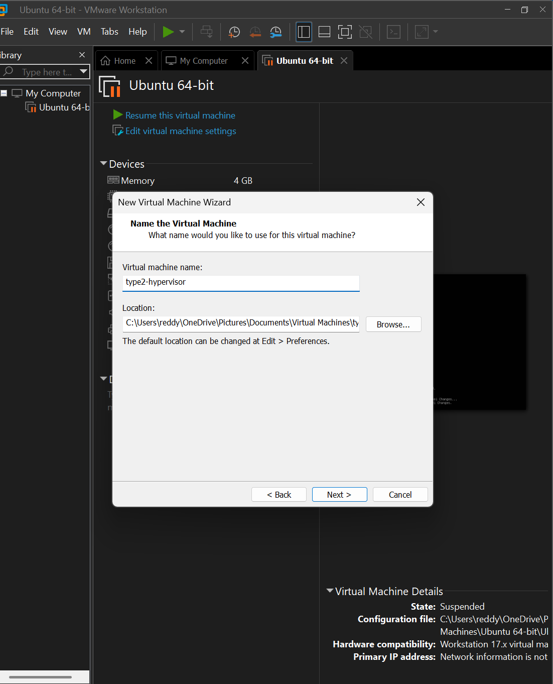

STEP2: ALLOCATE THE RAM AND THE STORAGE FOR THE VIRTUAL MACHINE 2
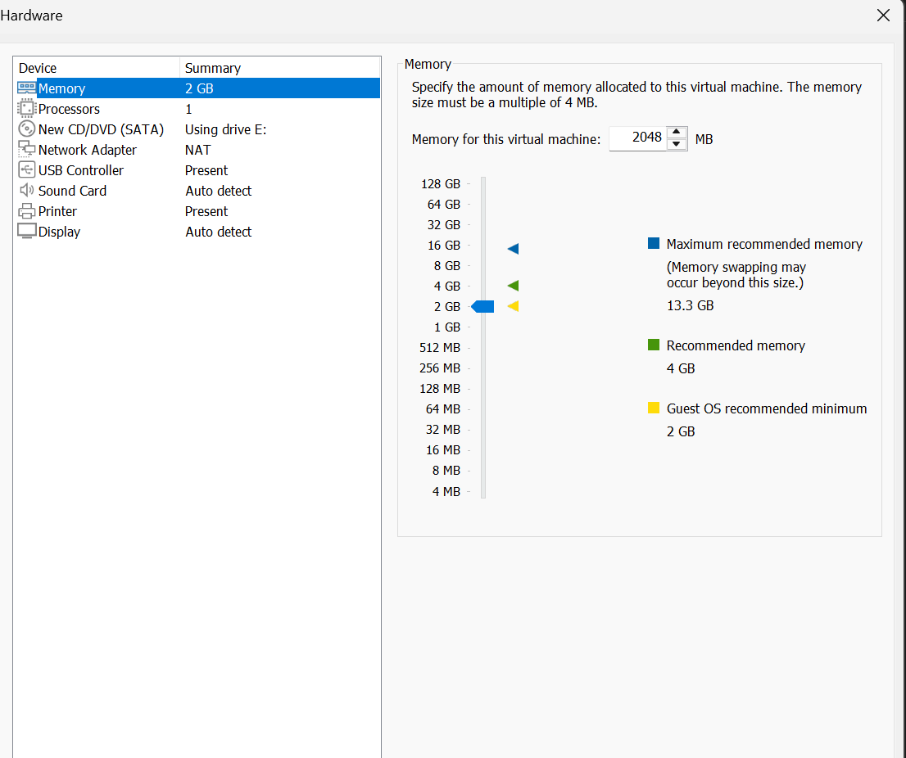
STEP 3: THESE ARE THE SPECIFICATIONS AND LAUNCH THE VM
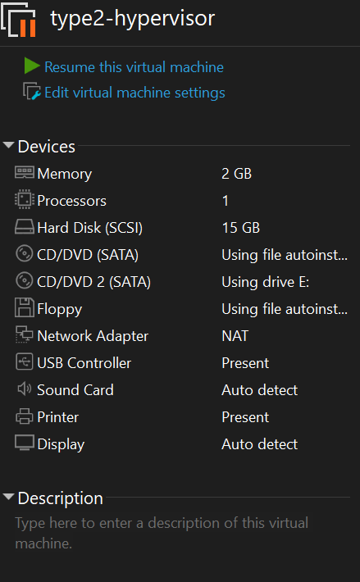

RESULTS:
A Virtual Machine with 1 CPU, 2 GB RAM, and 15 GB storage was successfully created using Oracle VirtualBox.

